Trip IOD In SYNC CAN Signals – BEV - CGEA1.3

Functional Description

This STSS shall be used by clusters which does not show Trip Summary screen. Instead Cluster will pass the information to SYNC to display Trip Summary screen. First usage ix Cx727 BEV program.

“Drive Cycle “(This Trip) Function calculates, stores, and displays the trip information at end of a drive cycle. A Drive Cycle Trip starts upon a transition of Operational-Mode from CRANK to NORMAL and ends upon a transition of Operational-Mode into CRANK. There is no customer reset for “This Trip” function.
The Information shall include the following:

- Trip Time (Calculated by Cluster, sent to SYNC)
- Trip Electric Vehicle Distance Achieved. (Calculated by Cluster, sent to SYNC)
- Trip total Distance (Calculated by Cluster, sent to TCU)

Note: This STSS is using parameters from the Fuel Economy STSS, “Fuel Economy (AFE, AFE Histogram, IFE, LT, DC, MyKey) - CGEA1.3 vx.x.doc” and Trip Computer - Timers - CGEA1.3_vx.x.doc. This STSS also assumes “Trip Computer – Odometer” is implemented so that correct distance units are transmitted.

Interfaces

Interface Context Diagram (I/O Block Diagram)

Trip Consumption Context Diagram
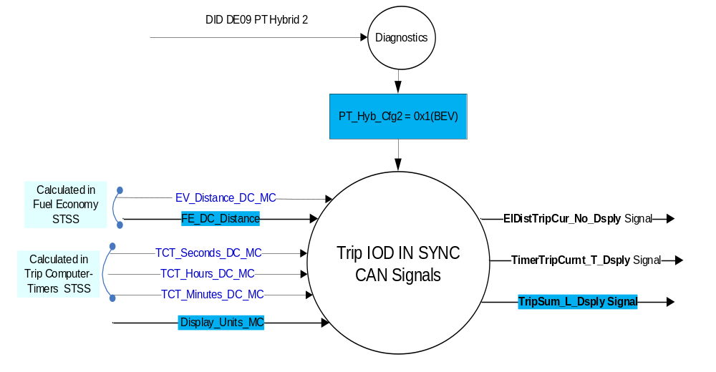

Inputs

Internal:
Parameters from Fuel Economy STSS, defined as an output in “Fuel Economy (AFE, AFE Histogram, IFE, LT, DC, MyKey) - CGEA1.3_vx.x.doc”:

  - EV_Distance_DC_MC
  - FE_DC_Distance

Parameters from Trip Computer Timers STSS, defined as an output in “Trip Computer - Timers - CGEA1.3_vx.x. doc”
  - TCT_Hours_DC_MC
  - TCT_Minutes_DC_MC
  - TCT_Seconds_DC_MC

Outputs

MUX signals

ElDistTripCur_No_Dsply Signal

Signal Name | Size (bits) | Detail | Units | Res. | Offset | State Encoded | Min | Max
ElDistTripCur_No_Dsply | 17 |  | unitless | 0.1 | 0 |  | 0  (0x0) | 13107.1  (0x1FFFF)
Note: This STSS works with “Trip Computer – Odometer” and this uses the signal ElDistTripUnit_D_Stat.

TimerTripCurnt_T_Dsply Signal

Signal Name | Size (bits) | Detail | Units | Res. | Offset | State Encoded | Min | Max
TimerTripCurnt_T_Dsply | 26 |  | seconds | 1 | 0 |  | 0 (0x00) | 67108863  (0x3FFFFFF)

TripSum_L_Dsply Signal

Signal Name | Size (bits) | Detail | Units | Res. | Offset | State Encoded | Min | Max
TripSum_L_Dsply | 16 |  | Km | 0.1 | 0 |  | 0  (0x0) | 6553.3  (0xFFFD)
 |  | No_Data_Available |  |  |  | 0xFFFE
 |  | Faulty |  |  |  | 0xFFFF

Function/Performance

Operational Modes

Mode | Differentiating Vehicle Conditions
Sleep Mode | Trip IOD In SYNC CAN Signals Off
Limited Mode | Trip IOD In SYNC CAN Signals Transmitted
Normal Mode | Trip IOD In SYNC CAN Signals Transmitted
Crank Mode | Trip IOD In SYNC CAN Signals Transmitted

Operation: Performance and Functional

Subsystem Algorithm Flowchart / State Diagram

IPC Display Parameter & Transmitted CAN Signal State Matrix

Display Parameter Source | Display Parameter Value | IPC Display Parameter | IPC Transmitted CAN Signal
Fuel Economy SSTS | EV_Distance_DC_MC | EV_Distance_DC | ElDistTripCur_No_Dsply signal
Fuel Economy SSTS | FE_DC_Distance | Total_Distance_DC | TripSum_L_Dsply
Trip Computer Timers SSTS | TCT_Hours_DC_MC | TCT_Hours_DC | TimerTripCurnt_T_Dsply
Trip Computer Timers SSTS | TCT_Minutes_DC_MC | TCT_Minutes_DC | TimerTripCurnt_T_Dsply
Trip Computer Timers SSTS | TCT_Seconds_DC_MC | TCT_Seconds_DC | TimerTripCurnt_T_Dsply

- This STSS is applicable for only BEV variation (PT_Hyb_Cfg2 = 0x1(BEV).

CAN Transmit Routine Flowchart – When CAN Bus is Awake

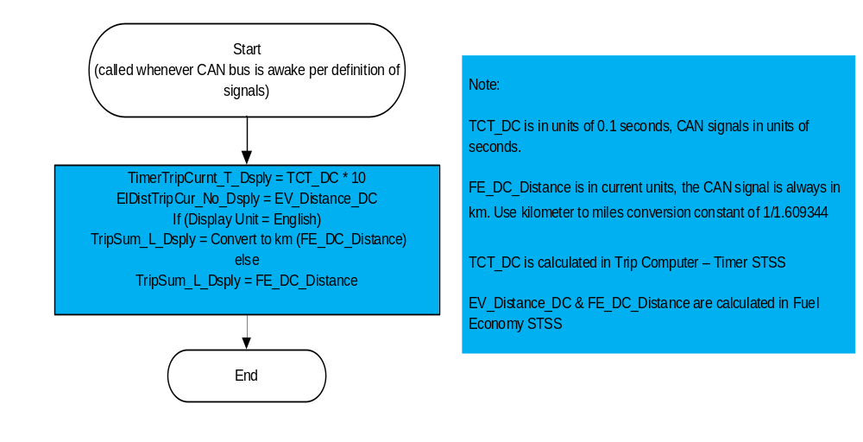

Function Safety Classification (EMC)

Class B

Memory Storage

Parameter Name | Description | Value at Battery connect | Value at  Module Wake-up
EV_Distance_DC_MC | Defined and calculated in Fuel Economy STSS. Variable stored in battery backed memory and used by Message Center for distance traveled under electrical power on the Drive Cycle basis in units of current M/C display setting. Range from 0.0 to 9999.9.. | 0 | Do Not Init
FE_DC_Distance | Defined and calculated in Fuel Economy STSS. Variable stored in battery backed memory and used by Message Center for Drive Cycle Trip Distance in units of current M/C display setting. Range from 0.0 to 999.9. | 0 | Do Not Init
TCT_Hours_DC_MC | Defined and calculated in Trip Computer Timers STSS  Integer variable stored in battery backed memory and used by Message Center for This Timer in units of hours. Range from 0 to 9999. | 0 | Do Not Init
TCT_Minutes_DC_MC | Defined and calculated in Trip Computer Timers STSS  Integer variable stored in battery backed memory and used by Message Center for This Timer in units of minutes. Range from 0 to 59. | 0 | Do Not Init
TCT_Seconds_DC_MC | Defined and calculated in Trip Computer Timers STSS  Integer variable stored in battery backed memory and used by Message Center for This Timer in units of seconds. Range from 0 to 59. | 0 | Do Not Init
TCT_DC | Internal variable used to track elapsed time during the execution of the Drive Cycle (“This Trip”) Stats algorithm. 32 Bit Integer variable with each count equal to 0.1 second. | 0 | Do Not Init
ElDistTripCur_No_Dsply Signal | Can signal transmitted by IPC for total drive cycle driven distance. | 0 | Do Not Init
TimerTripCurnt_T_Dsply Signal | Output CAN signal for Current Trip timer. This signal is in seconds and matches the numeric display on the cluster so that Center Stack can display the same number. | 0 | Do Not Init
TripSum_L_Dsply Signal | CAN signal transmitted by IPC for total drive cycle driven distance. | 0 | Do Not Init
Display_Units_MC | Parameter is defined as an output in Unit Selection Control Function STSS.  Input to this routine that controls display indicating units to the driver (i.e. when English: miles, mpg; when Metric: km, L/100 km, km/L). Parameter is to be stored in Battery Backed RAM. | Used Stored Value of Display_Unit_  Selection_Cfg  (See Display Unit Selection Control Function STSS) | Do Not Init

Prove Out

No

Reconfigurable Telltale

No

Message Center Msg

No

Error Handling

Missing Message Strategy

The signals will be declared missing as per the Diagnostics Section of this SPSS.

DTC states and history will be determined as per the Diagnostics Section of this SPSS.

Invalid Data Strategy

The signals will be declared invalid as per the Diagnostics Section of this SPSS.

DTC states and history will be determined as per the Diagnostics Section of this SPSS.
.

Diagnostics

Self Test

None

Engineering Test Mode

Reference section “Dealer / Engineering Test Mode (ETM)”

Part II Performance

Supported Diagnostic Trouble Codes (DTCs)
As per the Diagnostics Section of this SPSS

DID DExx

Block  Num | Block Description | Byte(s) | Bits | State: Description | "0" | "1" | Default | Comments/  Information
$09 | Option Content (B&A) |  | 3 | PT Hybrid2(PT_Hyb_Cfg2)  0x0 = Non-Hybrid  0x1 = BEV  0x2 = FHEV  0x3 = PHEV  0x4 = MHEV |  |  | 0x0 | Default from cluster plant to be 0x0 if cluster can be used on a Non-Hybrid.

Reference Specification

Fuel Economy (AFE, AFE Histogram, IFE, LT, DC, MyKey) - CGEA1.3 vx.x.doc
Trip Computer - Timers – CGEA 1.3_vx.x.doc

Operational Modes and Voltage Range Strategies .doc

Display Unit Selection Control Function .doc

Revision History

SPSS Module Revision History

Revision Level | Name | Change Description | Date
1.0 | H. Sharma | This STSS is created to provide Trip Summary distance and Timer information to SYNC through CAN signal. This Request was approved offline by Scott Watkins on 11/20/2019.  Current target program for this STSS is Cx727 and can be used for other programs in future. | 11/20/2019
1.1 | H. Sharma | - Added Missing requirement ‘Operational Mode’ is added to new  Section 1.3.1  - Section 1.3.2.1.2 CAN Transmit Routine Flowchart – When CAN Bus is Awake, is updated to add Trip Distance signal.  Changes marked in yellow color. | 11/21/2019
1.2 | H. Sharma | This update is performed to fill existing gap where Total Trip Distance is not transmitted by IPC because neither “Trip Summary and Drive Cycle (This Trip) Function - BEV - CGEA1.3” nor “Fuel Economy (AFE AFE Histogram IFE LT DC MyKey) - CGEA1.3” were included in Cx727 FIP.  With this update ‘TripSum_L_Dsply’ will be be supported on BEV’s with this STSS or the other STSS mentioned above. This change request was triggered by email from Felipe Castrejon.  In this update we have added ‘TripSum_L_Dsply’ to be transmitted from IPC to TCU so that Sync can display this information, if required.  Changes are marked in Turquoise color. DICC tracking #562.  - This STSS is marked BEV specific  - Context diagram is updated to add new output CAN signal and two new input parameters from other STSS’s  - New section 1.2.3.1.3 added for new CAN signal.  - Section 1.3.2.1.1 updated to add FE_DC_Distance  - Section 1.3.2.1.2 is updated to add FE_DC_Distance display  - Section 1.3.2.3 updated to add new parameters. | 06/08/2020

